MAJOR PROJECT

WINE QUALITY ANALYSIS

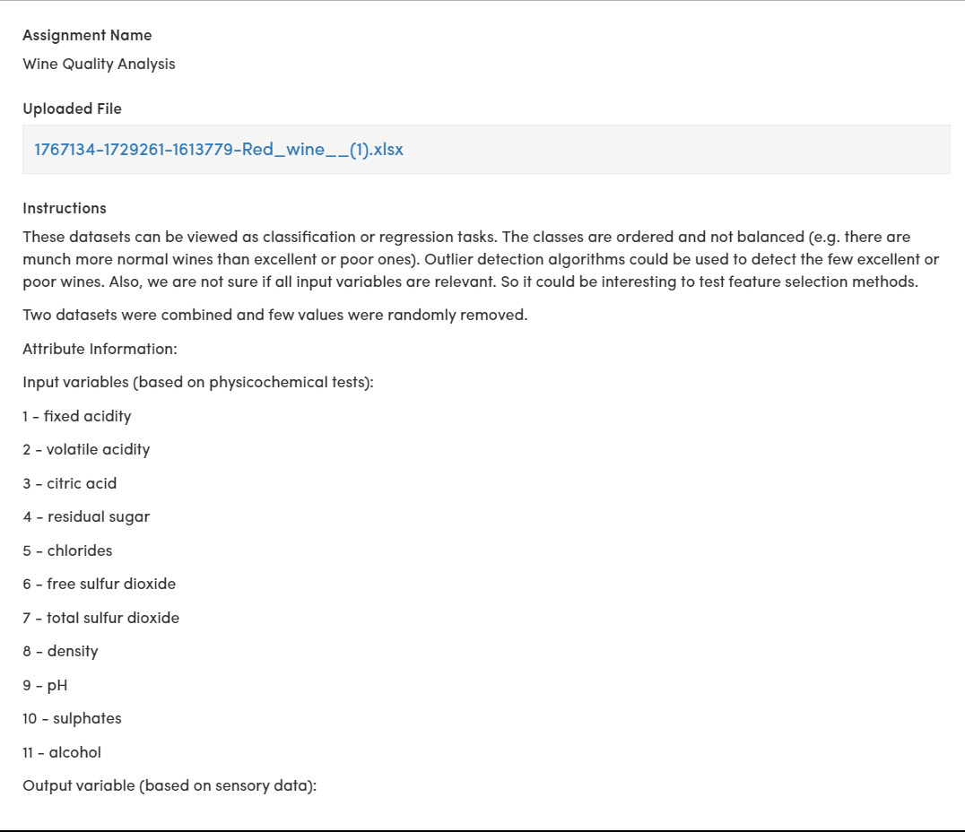

CODE:

# Import necessary libraries

import pandas as pd

import numpy as np

import matplotlib.pyplot as plt

from sklearn.model_selection import train_test_split

from sklearn.preprocessing import StandardScaler

from sklearn.ensemble import RandomForestClassifier

from sklearn.metrics import classification_report, confusion_matrix, accuracy_score

# Load the dataset

data = pd.read('Wine.csv')

print(data.head()) # To view the first few rows of the dataset

print(data.info()) # To get information about data types and missing values

print(data.describe()) # To get statistical summary of the dataset

print(data.isnull().sum())

X = data.iloc[:, :-1] # All columns except the last one (quality)

y = data['quality'] # The quality column

X_train, X_test, y_train, y_test = train_test_split(X, y, test_size=0.2, random_state=42)

sc = StandardScaler()

X_train = sc.fit_transform(X_train)

X_test = sc.transform(X_test)

classifier = RandomForestClassifier(n_estimators=100, random_state=42)

classifier.fit(X_train, y_train)

y_pred = classifier.predict(X_test)

print("Confusion Matrix:\n", confusion_matrix(y_test, y_pred))

print("Classification Report:\n", classification_report(y_test, y_pred))

print("Accuracy Score:", accuracy_score(y_test, y_pred))

feature_importances = pd.Series(classifier.feature_importances_, index=X.columns)

feature_importances.nlargest(10).plot(kind='barh')

plt.title("Top 10 Important Features")

plt.show()